Title: Fewzion Incident Response Plan |  | Version: 1.0
Effective Date: 01/09/14 | Approval Date: 01/09/14 | Review: Annual

Incident Response Plan
This response plan provides a summary of the incident handling process of Fewzion.
Definitions
Incident – an unplanned interruption or reduction in the quality of an IT service.
Incident Ticket – an electronic ticket that is uniquely identify the incident in OnTime system.
OnTime – the service desk software used by Fewzion.
Severity – a simple code assigned to incidents indicating the seriousness of their impact on the quality of IT service and business processes.
Reporting an Incident
Customers can use several ways to report an incident to Fewzion’s Support Team:
- Customers can login to Customer Portal and report the incident by the Portal,
- Customers can send an email with the problem to support@fewzion.com or
- Customers can use the Feedback gadget of Fewzion on their site.
All Incidents will be recorded in OnTime.

Incident Response Process
When an incident recorded in OnTime by an Incident Ticket, Fewzion’s Support Team will evaluate it by assigning Severity to the incident.
Severity:
- Critical – where the incident has caused disruptions to the Customer's critical business operations;
- High impact – where the incident has caused a significant disruption to the Customer's business operations, but where the problem can be worked around or a short delay in response is acceptable;
- Medium impact – where the incident is an important issue, but has not caused a significant disruption to the Customer's business operations;
- Low impact – where the incident is a non-critical issue
- No impact or Development Request – where the Customer has requested a new feature or wishes to propose changes to the Software;
Example of an Incident Ticket in OnTime:
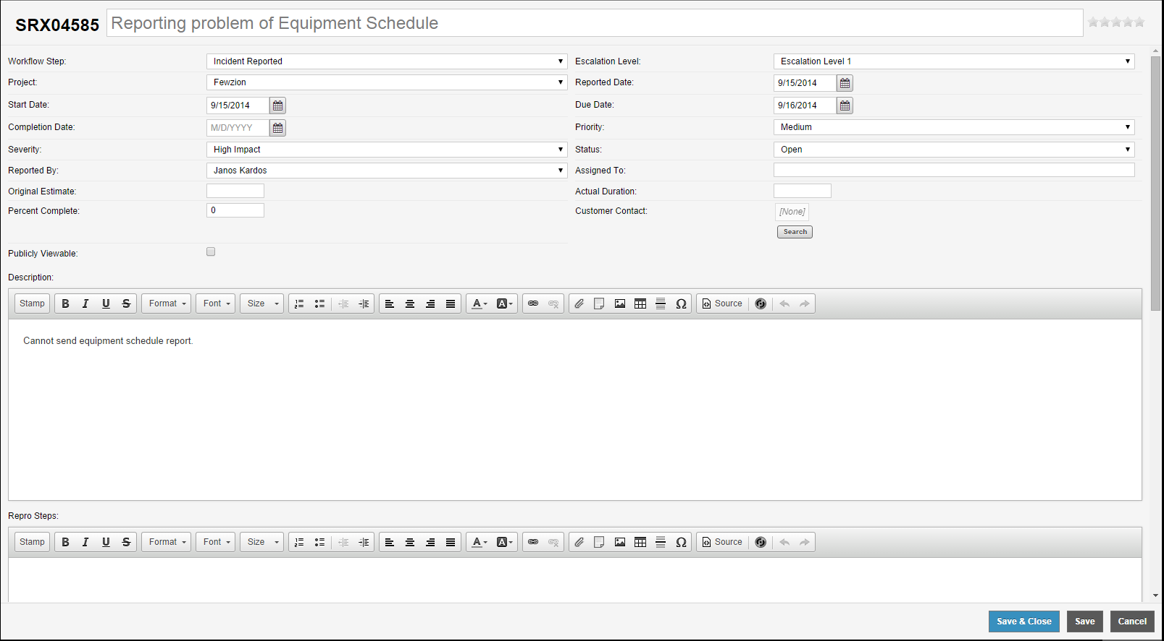
Fewzion’s Support Team will assign the incident to the adequate support member to solve the problem within the resolution time.
Severity defines the resolution time of an incident by SLA. We have individual Service Level Agreements with clients. See an example below.
 | Response | Investigation | Resolution
Critical | Two (2) hours | Four (4) hours | Eight (8) hours
High | Two (2) hours | Eight (8) hours | Sixteen (16) hours
Medium | Four (4) hours | Sixteen (16) hours | Thirty-two (32) hours
Low | Eight (8) hours | Forty-eight (48) hours | 1 week
Development Request | As agreed | As agreed | As agreed

This SLA need to meet with Response Targets in respect of 95% of all logged incidents; Investigation Targets in respect of 90% of all logged incidents; and Resolution Targets in respect of 80% of all logged incidents.
SLA Availability Target: Fewzion will be available for use by the Customer 99% of the time, excluding agreed maintenance and upgrade windows and excluding any downtime as a result of an unavailable server, network or other factor outside of the control of the Supplier. The “availability percentage” shall be calculated as follows:
Z = ((t – p - i) – a)) / (t – p - i) x 100
Z is the availability percentage, where:
T = total number of core operating hours for the calendar month
P = total number of hours for excluded interruptions during a calendar month
I = total number of hours for application issues for the calendar month
A = total number of hours the system was not available during core

Incident management: During the problem solving, the support person evaluates the incident by root cause analysis, establish remediation steps and communication with the Customer.
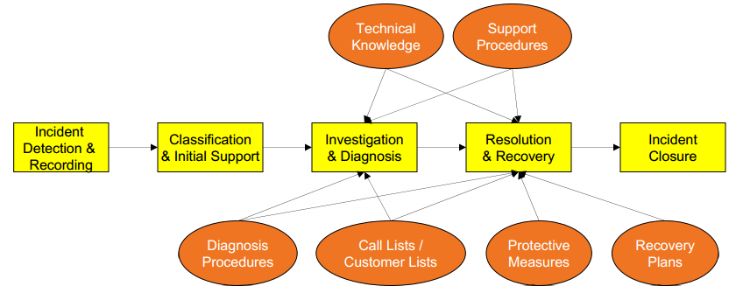
This support person might escalate this problem to another level of support or assign it to other member of the support team.
When the incident is resolved and tested by the Customer, the support person can close the Incident Ticket.

